**Module 2 Challenge corrections:**

**Deliverable 1: Refactor VBA Code and Measure Performance (80 points)**

**Deliverable 1 Instructions**

Use your knowledge of VBA and the starter code provided in this Challenge to refactor the Module2_VBA_Script so you loop through the data one time and collect all of the information. Your refactored code should run faster than it did in this module.

1. Download the challenge_starter_code.vbs file and rename it VBA_Challenge.vbs.
2. Create a folder called “Resources” to hold the run-time pop-up messages that you’ll screenshot after running refactored analyses for 2017 and 2018.
3. Rename the green_stocks.xlsm file that you used in this module as VBA_Challenge.xlsm.
4. Add the VBA_Challenge.vbs script to the Microsoft Visual Basic editor.
5. Use the steps below to add code where indicated by the numbered comments in the starter code file.

**Step 1a:**

* Create a tickerIndex variable and set it equal to zero before iterating over all the rows. You will use this tickerIndex to access the correct index across the four different arrays you’ll be using: the tickers array and the three output arrays you’ll create in Step 1b.

**Step 1b:**

* Create three output arrays: tickerVolumes, tickerStartingPrices, and tickerEndingPrices.
  + The tickerVolumes array should be a Long data type.
  + The tickerStartingPrices and tickerEndingPrices arrays should be a Single data type.

**Step 2a:**

* Create a for loop to initialize the tickerVolumes to zero.

**Step 2b:**

* Create a for loop that will loop over all the rows in the spreadsheet.

**Step 3a:**

* Inside the for loop in Step 2b, write a script that increases the current tickerVolumes (stock ticker volume) variable and adds the ticker volume for the current stock ticker.
  + Use the tickerIndex variable as the index.

If you’d like a hint on how to increase the current tickerVolumes by using the tickerIndex variable as the index, that’s totally okay. If not, that’s great too. You can always revisit this later if you change your mind.

**Step 3b:**

* Write an if-then statement to check if the current row is the first row with the selected tickerIndex. If it is, then assign the current starting price to the tickerStartingPrices variable.

**Step 3c:**

* Write an if-then statement to check if the current row is the last row with the selected tickerIndex. If it is, then assign the current closing price to the tickerEndingPrices variable.

**Step 3d:**

* Write a script that increases the tickerIndex if the next row’s ticker doesn’t match the previous row’s ticker.

**Step 4:**

* Use a for loop to loop through your arrays (tickers, tickerVolumes, tickerStartingPrices, and tickerEndingPrices) to output the “Ticker,” “Total Daily Volume,” and “Return” columns in your spreadsheet.

Finally, run the stock analysis, then confirm that your stock analysis outputs for 2017 and 2018 are the same as they were in the module (as shown in the images below). In your Resources folder, save the pop-up messages showing elapsed run time for the refactored code as VBA_Challenge_2017.png and VBA_Challenge_2018.png. Then, save the changes to your workbook.

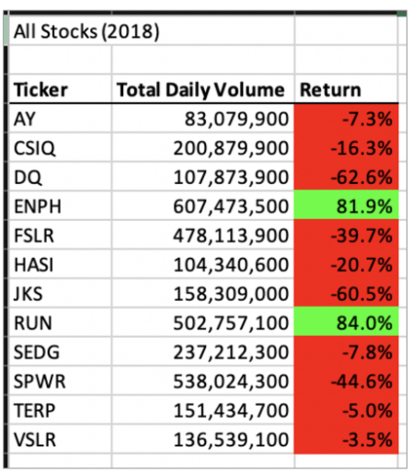

### Deliverable 1 Requirements

You will earn a perfect score for Deliverable 1 by completing all requirements below:

* The tickerIndex is set equal to zero before looping over the rows. **(5 pt)**.
* Arrays are created for tickers, tickerVolumes, tickerStartingPrices, and tickerEndingPrices **(15 pt)**.
* The tickerIndex is used to access the stock ticker index for the tickers, tickerVolumes, tickerStartingPrices, and tickerEndingPrices arrays **(15 pt)**.
* The script loops through stock data, reading and storing all of the following values from each row: tickers, tickerVolumes, tickerStartingPrices, and tickerEndingPrices **(25 pt)**.
* Code for formatting the cells in the spreadsheet is working **(5 pt)**.
* There are comments to explain the purpose of the code **(5 pt)**.
* The outputs for the 2017 and 2018 stock analyses in the VBA_Challenge.xlsm workbook match the outputs from the AllStockAnalysis in the module **(5 pt)**.
* The pop-up messages showing the elapsed run time for the script are saved as VBA_Challenge_2017.png and VBA_Challenge_2018.png **(5 pt)**.

## ****Deliverable 2: Written Analysis of Results (20 points)****

### Deliverable 2 Instructions

Initialize your repository with a README, and write your analysis of Deliverable 1.

**NOTE**

This [documentation (Links to an external site.)](https://help.github.com/en/articles/basic-writing-and-formatting-syntax) provides more information about basic writing and formatting syntax for GitHub.

For your written analysis, be sure to use complete and coherent sentences. Your written analysis should contain three sections, which cover the following:

1. Overview of Project: Explain the purpose of this analysis.
2. Results: Using images and examples of your code, compare the stock performance between 2017 and 2018, as well as the execution times of the original script and the refactored script.
3. Summary: In a summary statement, address the following questions.
   1. What are the advantages or disadvantages of refactoring code?
   2. How do these pros and cons apply to refactoring the original VBA script?

### Deliverable 2 Requirements

#### Structure, Organization, and Formatting Requirements (8 points)

The written analysis contains the following structure, organization, and formatting:

* There is a title, and there are multiple paragraphs **(2 pt)**.
* Each paragraph has a heading **(2 pt)**.
* There are subheadings to break up text **(2 pt)**.
* Links are working, and images are formatted and displayed where appropriate **(2 pt)**.

### Analysis Requirements (12 points)

The written analysis has the following:

* Overview of Project
  + The purpose and background are well defined **(2 pt)**.
* Results
  + The analysis is well described with screenshots and code **(4 pt)**.
* Summary
  + There is a detailed statement on the advantages and disadvantages of refactoring code in general **(3 pt)**.
  + There is a detailed statement on the advantages and disadvantages of the original and refactored VBA script **(3 pt)**.

## Submission

Once you’re ready to submit, make sure to check your work against the rubric to ensure you are meeting the requirements for this Challenge one final time. It’s easy to overlook items when you’re in the zone!

As a reminder, upload the following deliverables to your stock-analysis GitHub repository:

* Deliverable 1: Refactor VBA code and measure performance
  + The VBA_Challenge.xlsm workbook
  + The Resources folder with VBA_Challenge_2017.png and VBA_Challenge_2018.png
* Deliverable 2: A written analysis of your results (README.md)

To submit your challenge assignment for grading in Bootcamp Spot, click Start Assignment, click the Website URL tab, then provide the URL of your stock-analysis GitHub repository, and then click Submit. Comments are disabled for graded submissions in BootCampSpot. If you have questions about your feedback, please notify your instructional staff or the Student Success Manager. If you would like to resubmit your work for an improved grade, you can use the **Re-Submit Assignment** button to upload new links. You may resubmit up to 3 times for a total of 4 submissions.

**IMPORTANT**

Once you receive feedback on your Challenge, make any suggested updates or adjustments to your work. Then, add this week’s Challenge to your professional portfolio.